1 - basic agent: it greets us (adk web command)

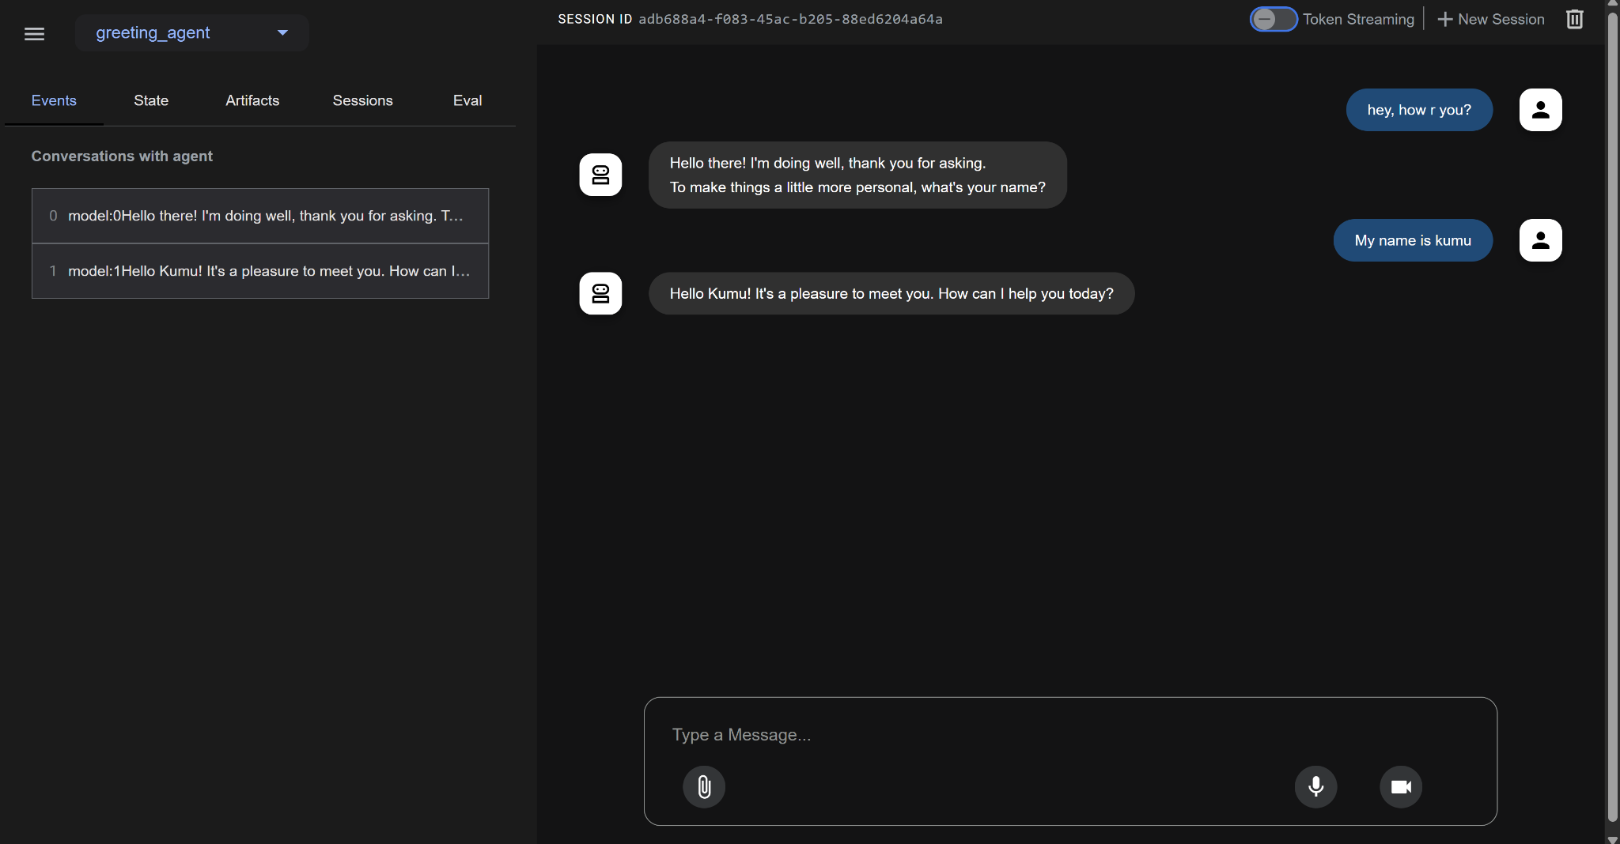

2 - a. tool agent: it uses google search tool to search something latest

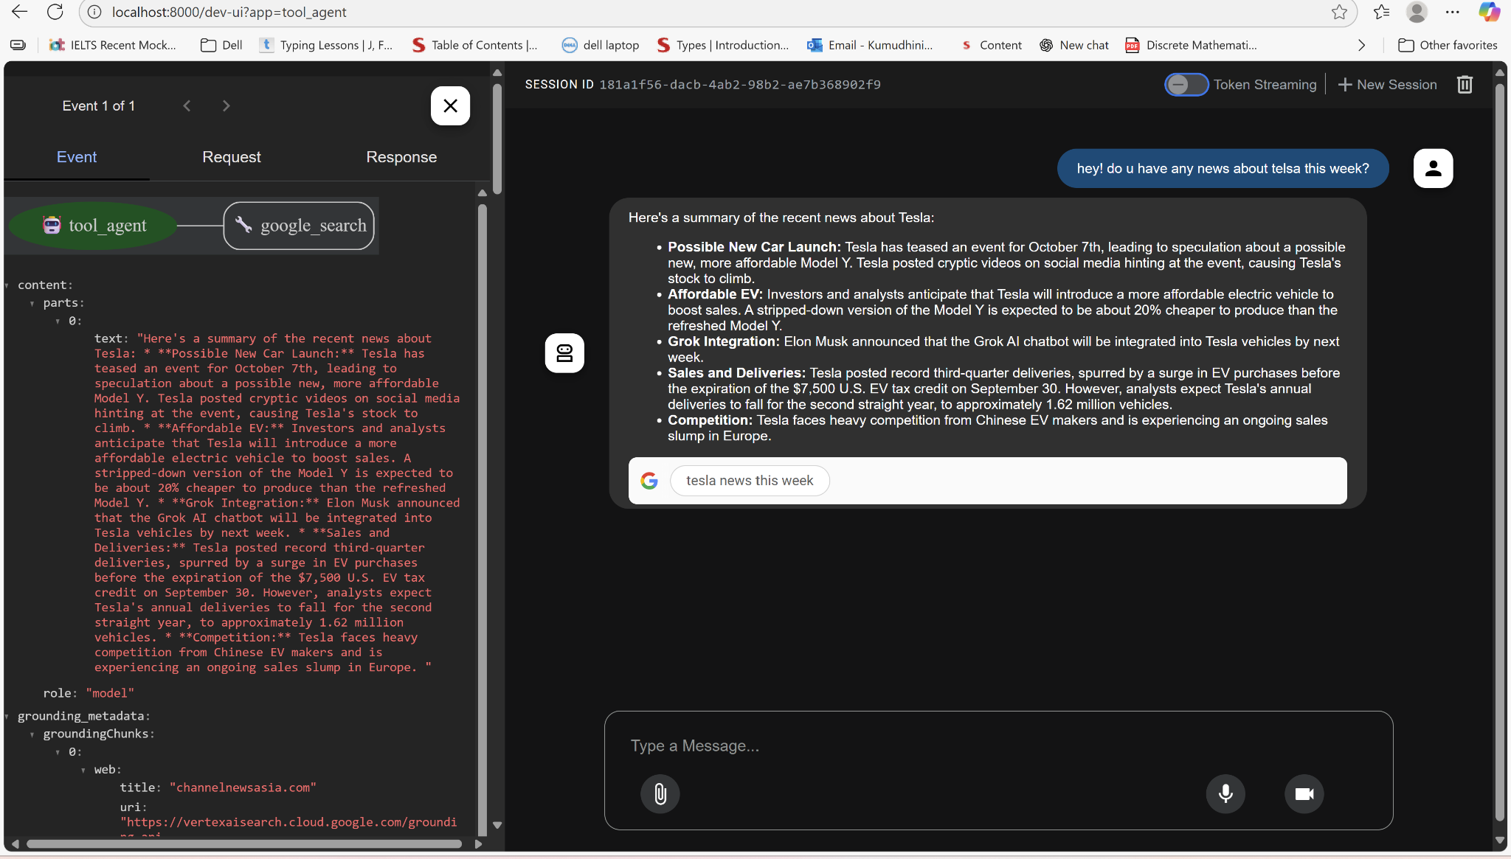

b. get current time - custom-made tool that returns the current time

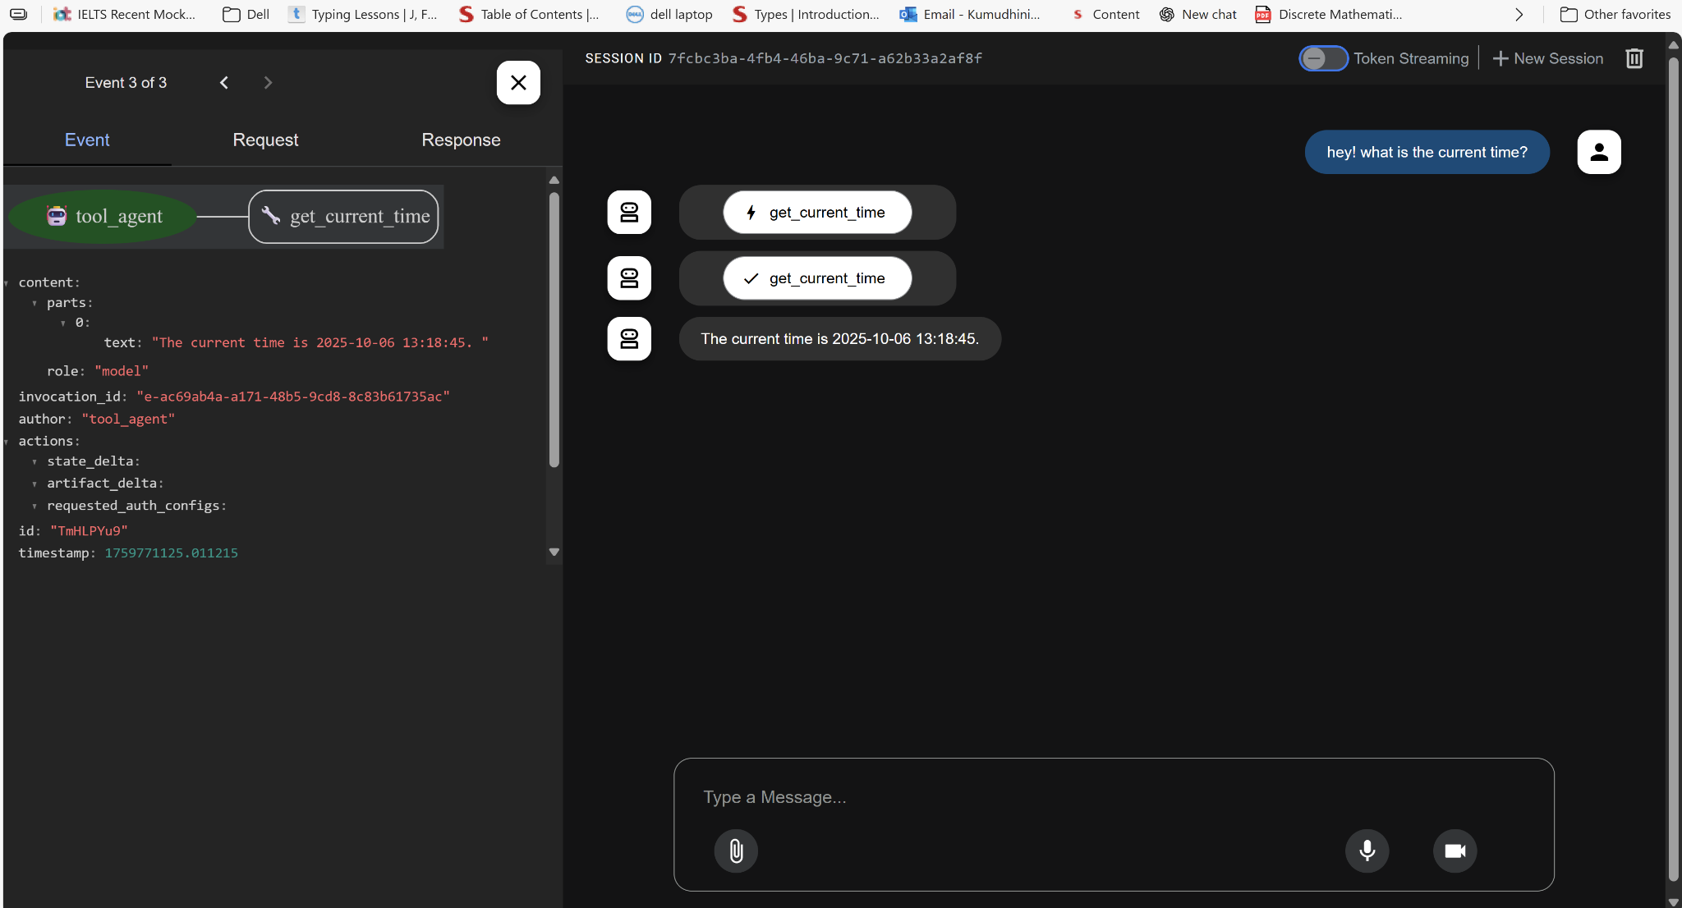

3 - litellm-agent: uses OpenAI model to pick a dad joke from the list I provided.

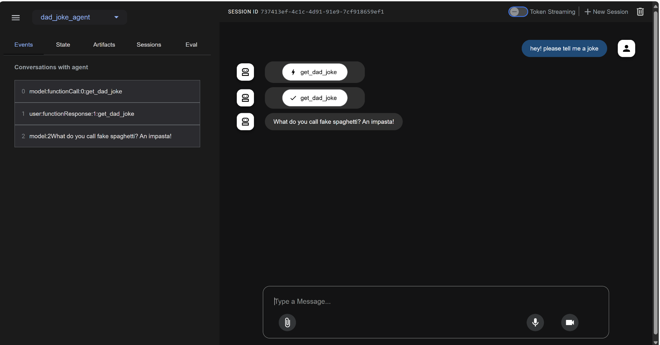

4 - structured-output-agent: agents always generate proper output schema and save the data exactly where you want in state (tab on the left)

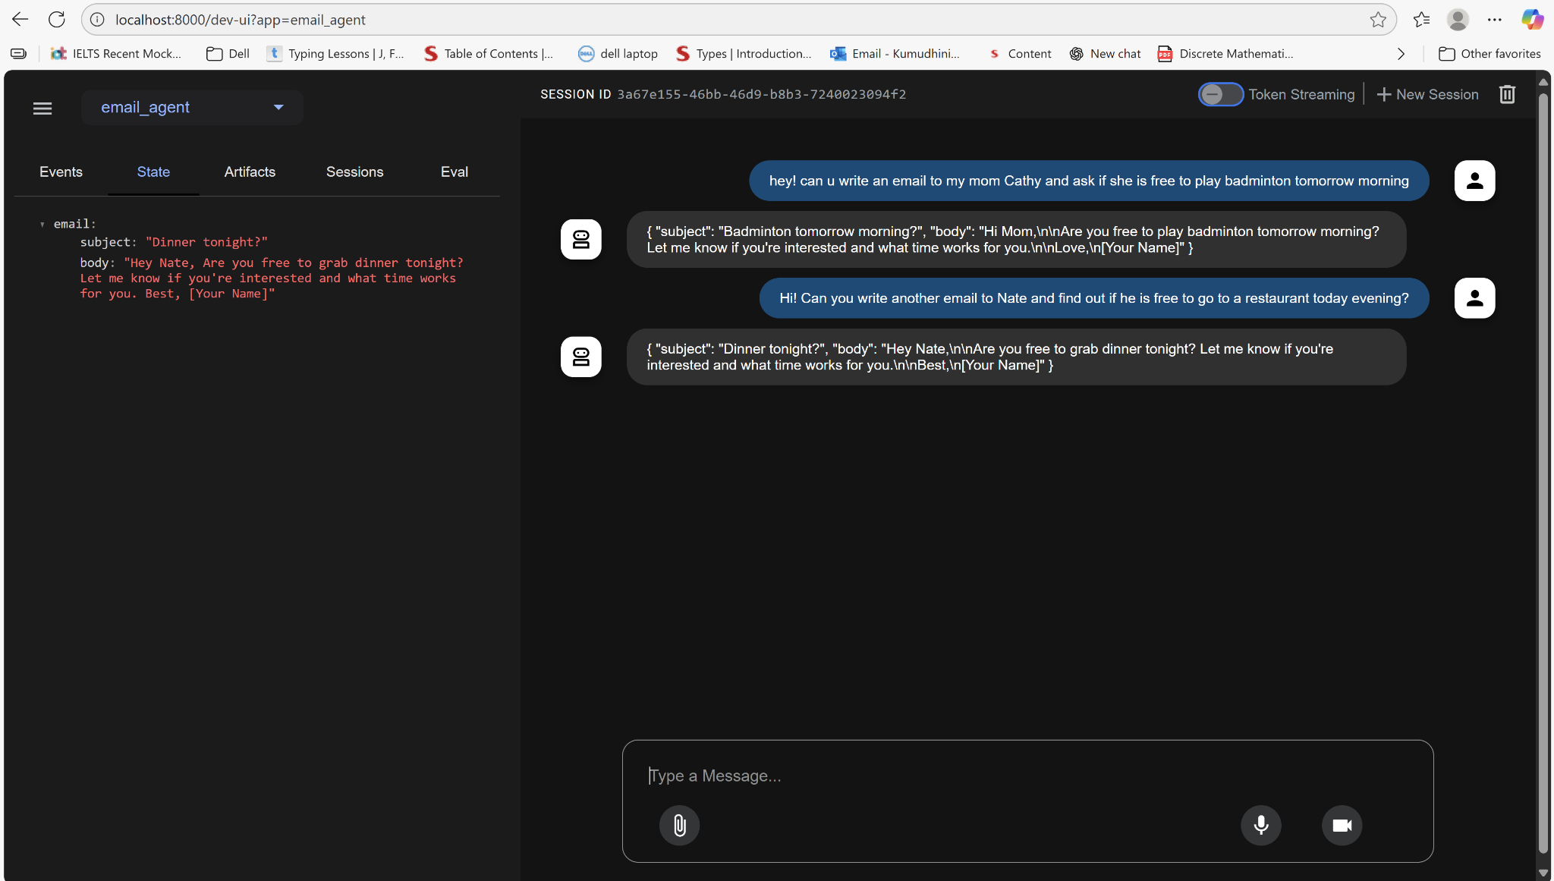

5 - session and state: creates a session, state and runner, when we run the py file, it provides with the final response

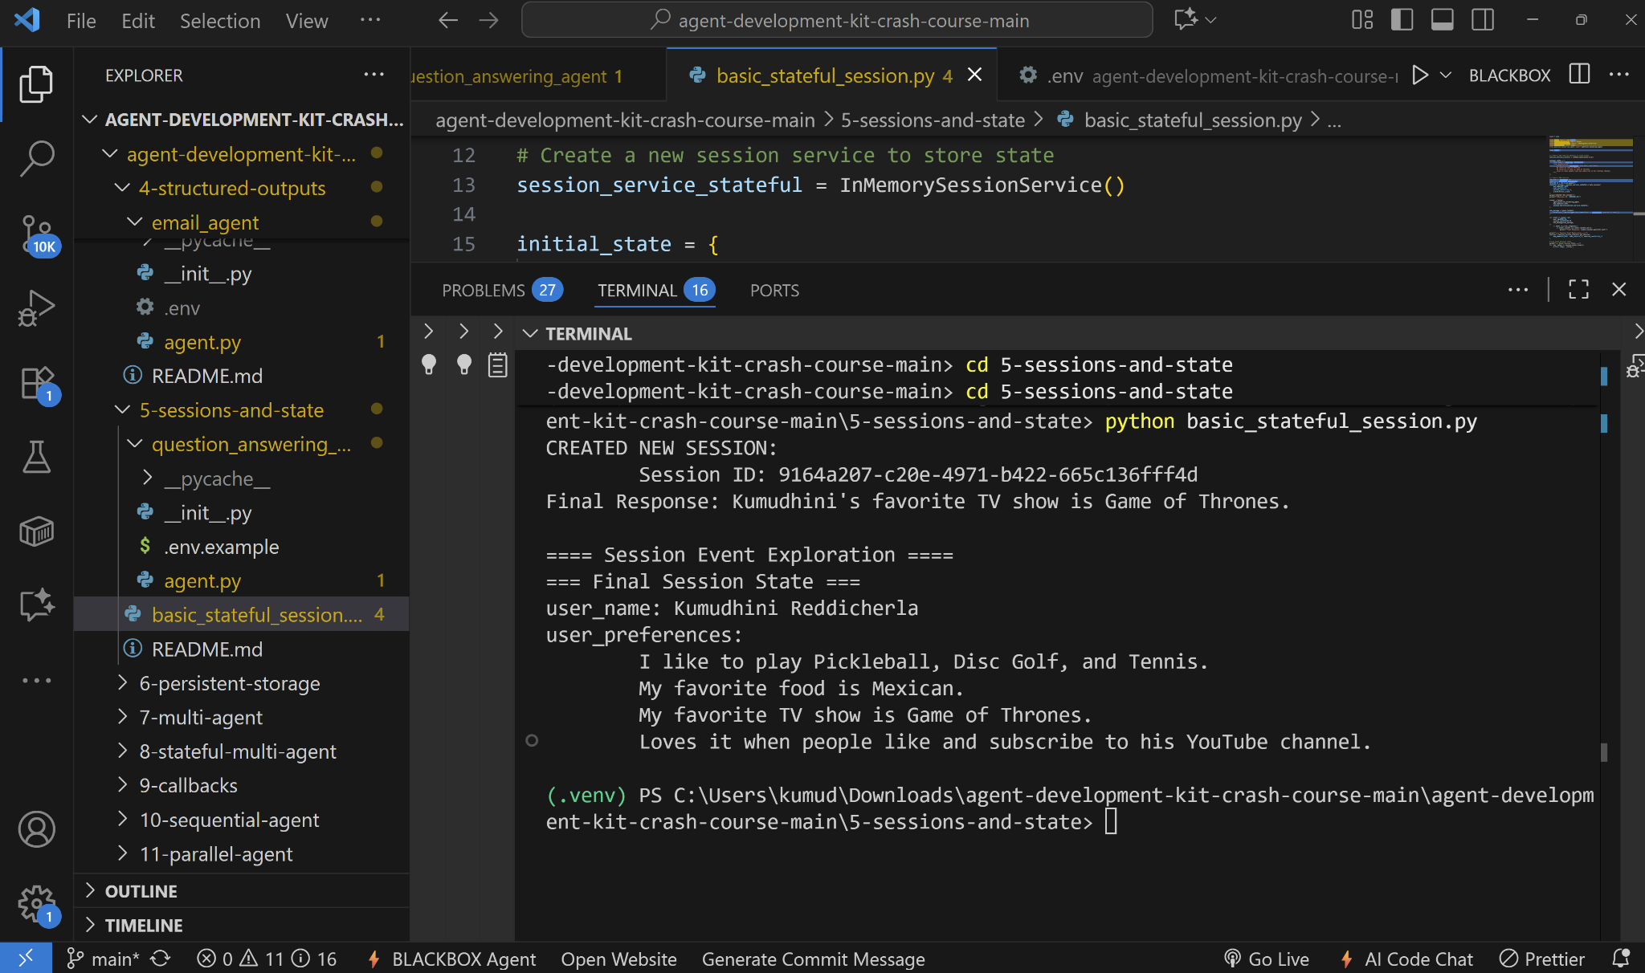

6 - persistent-storage: when we run the [main.py](http://main.py) file, we enter the reminders, and it remembers the reminders and does CRUD methods on them and saves in the database

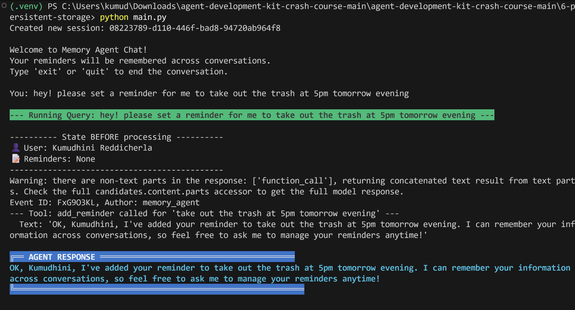

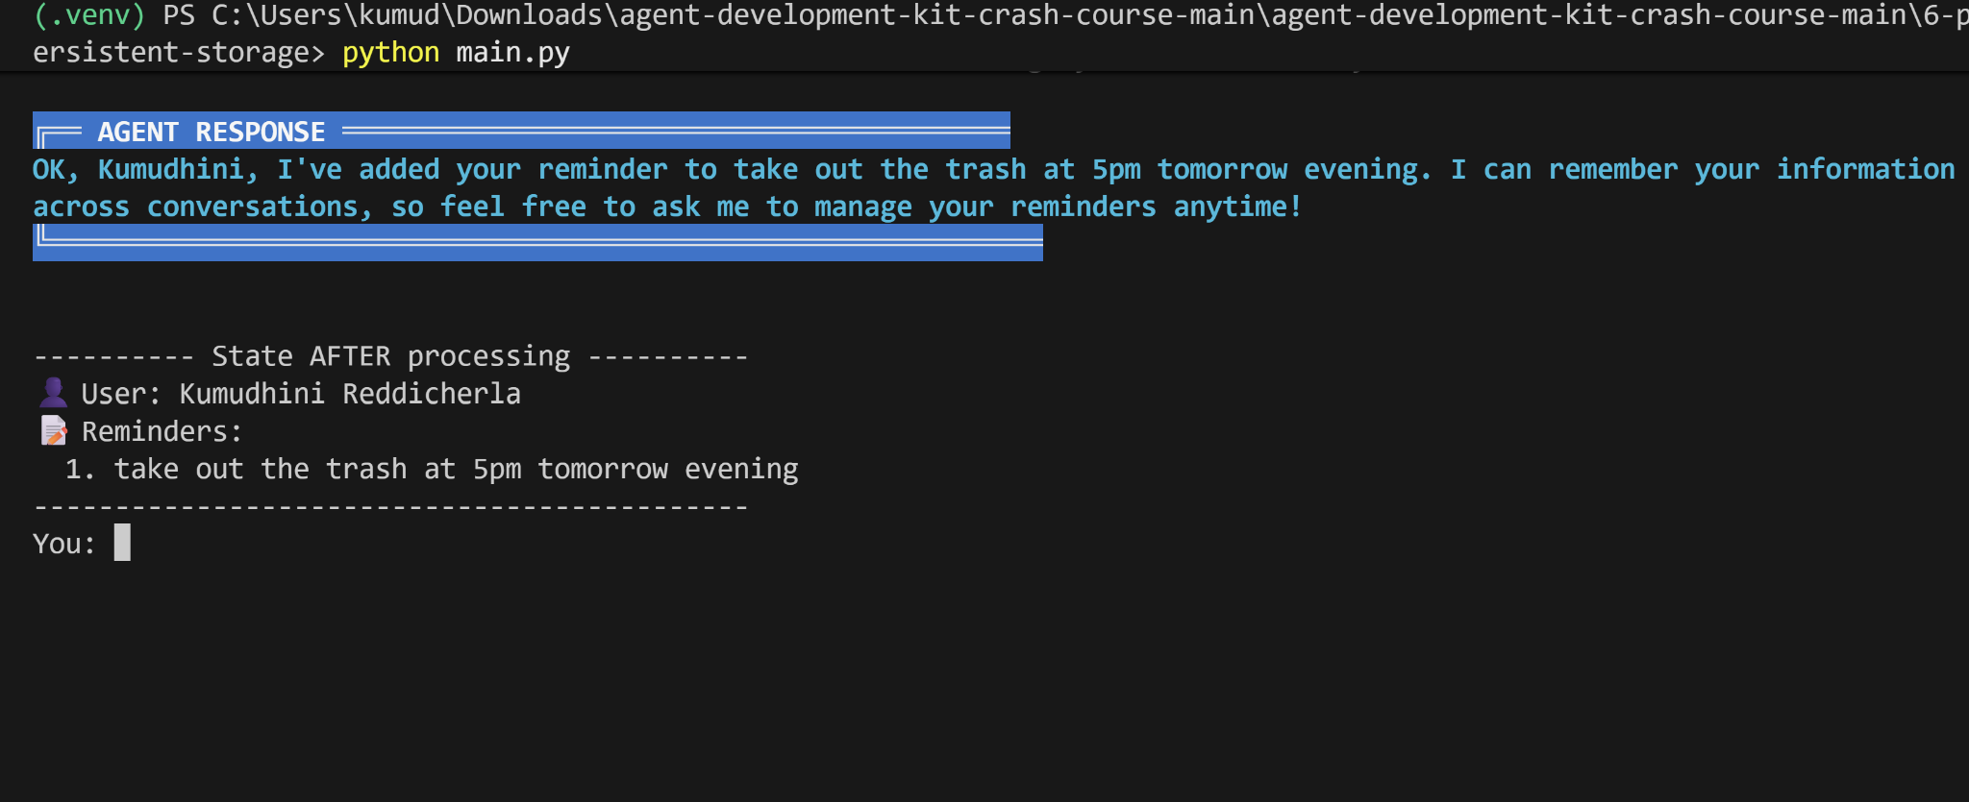

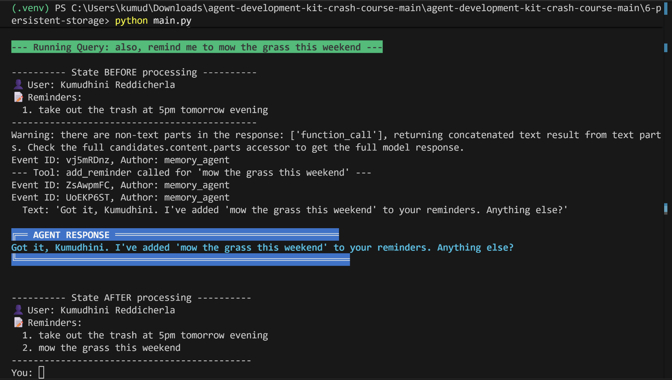

to quit: you just type quit to end the session. the data will already be saved to the database

database:  
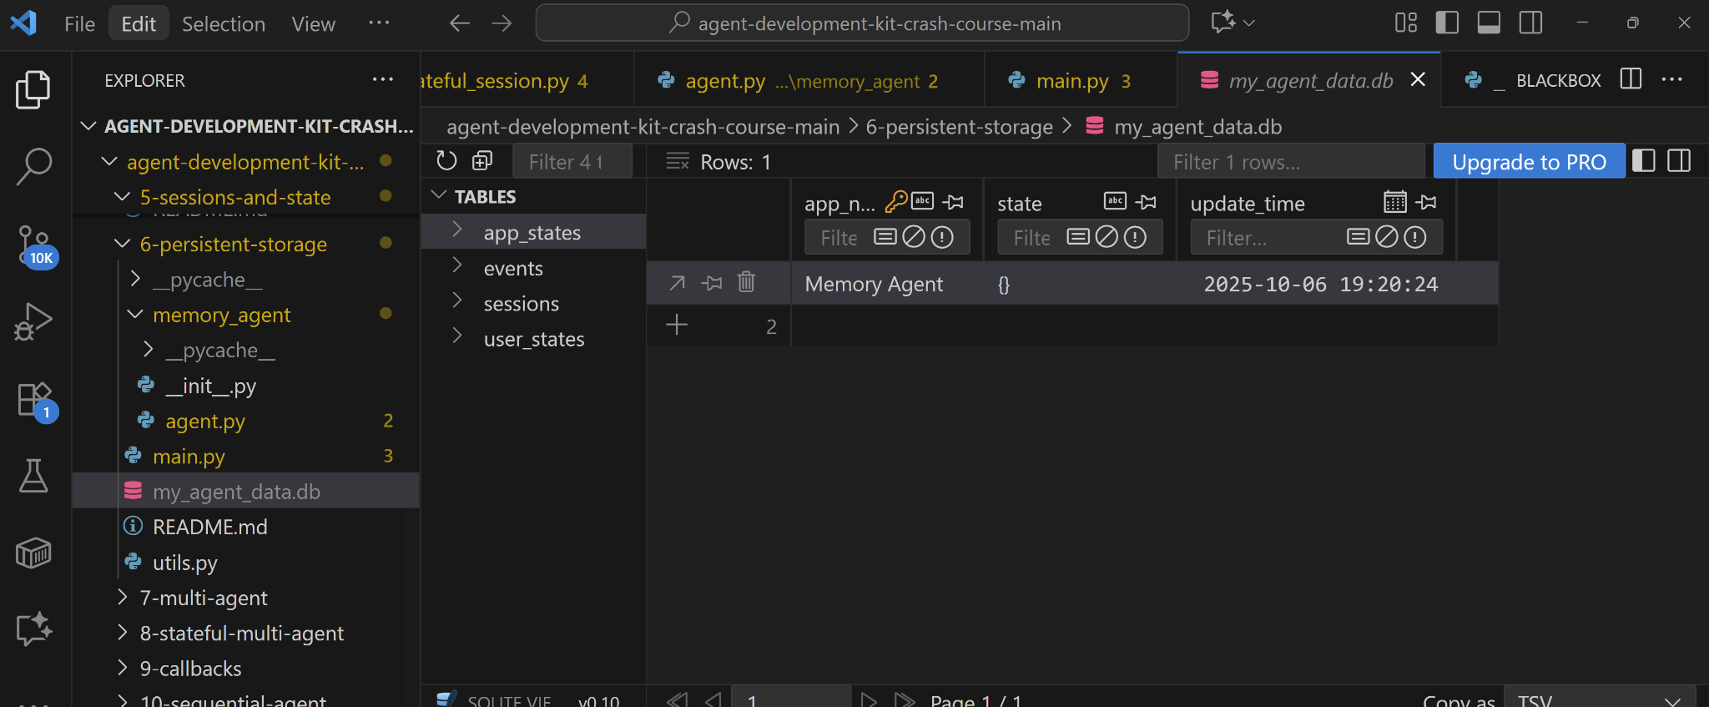

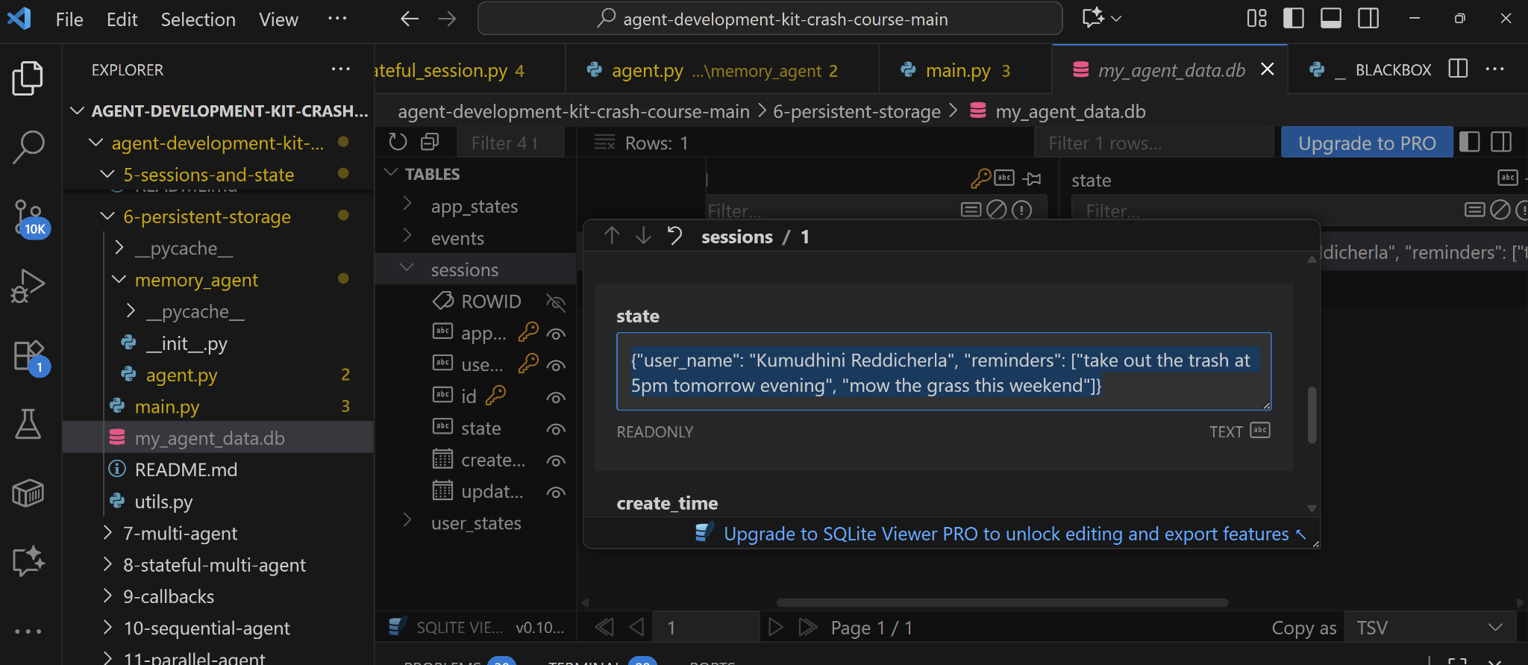

after re running the [main.py](http://main.py) file:

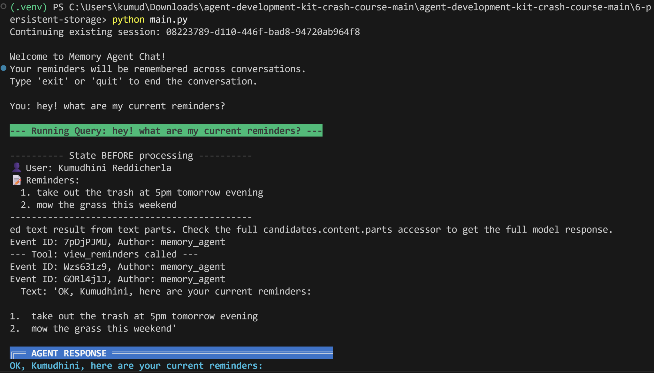

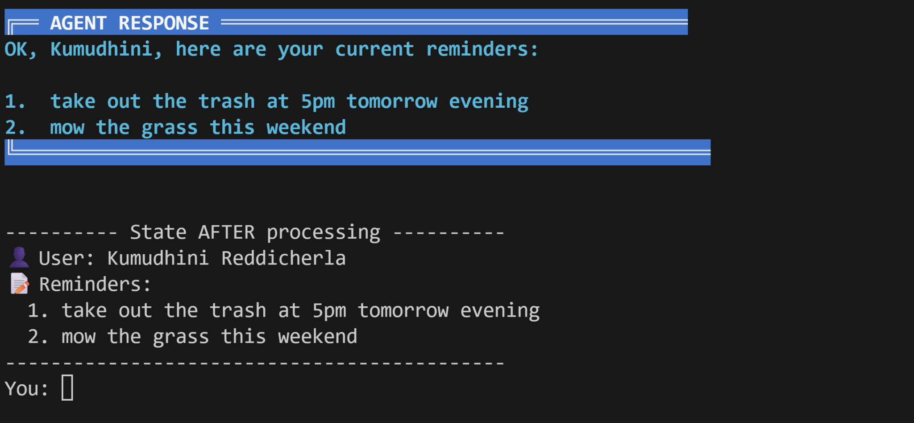

7 - multi-agent: There is a root agent which is connected to sub-agents News agent, current time agent, stocks agent, funny nerd agent. When the user asks a question to the manager agent, it delegates on which agent to choose and calls it, and responses to the prompt.

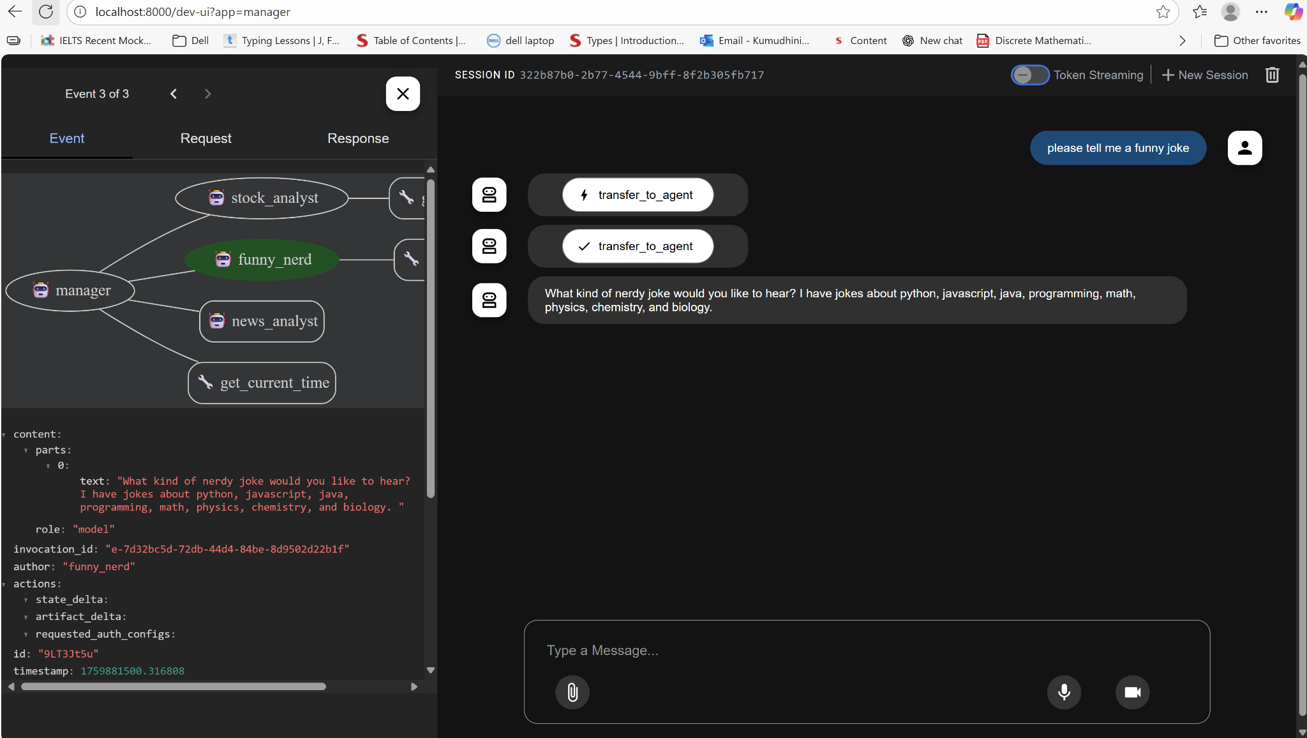

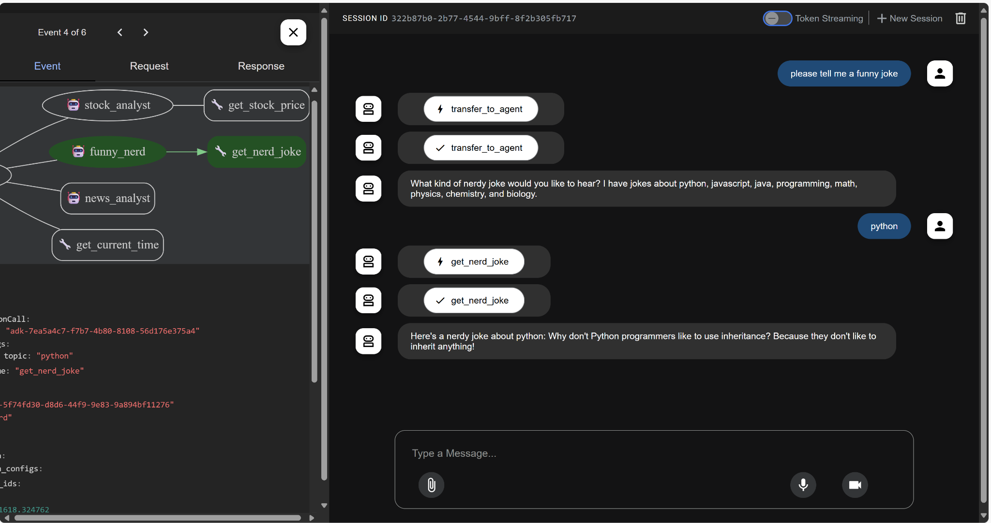

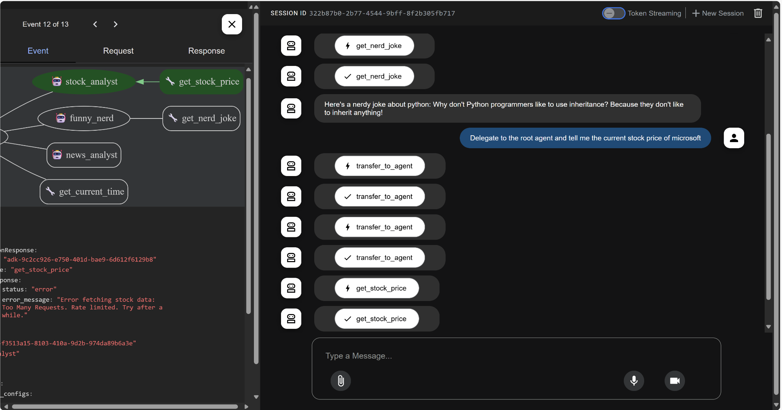

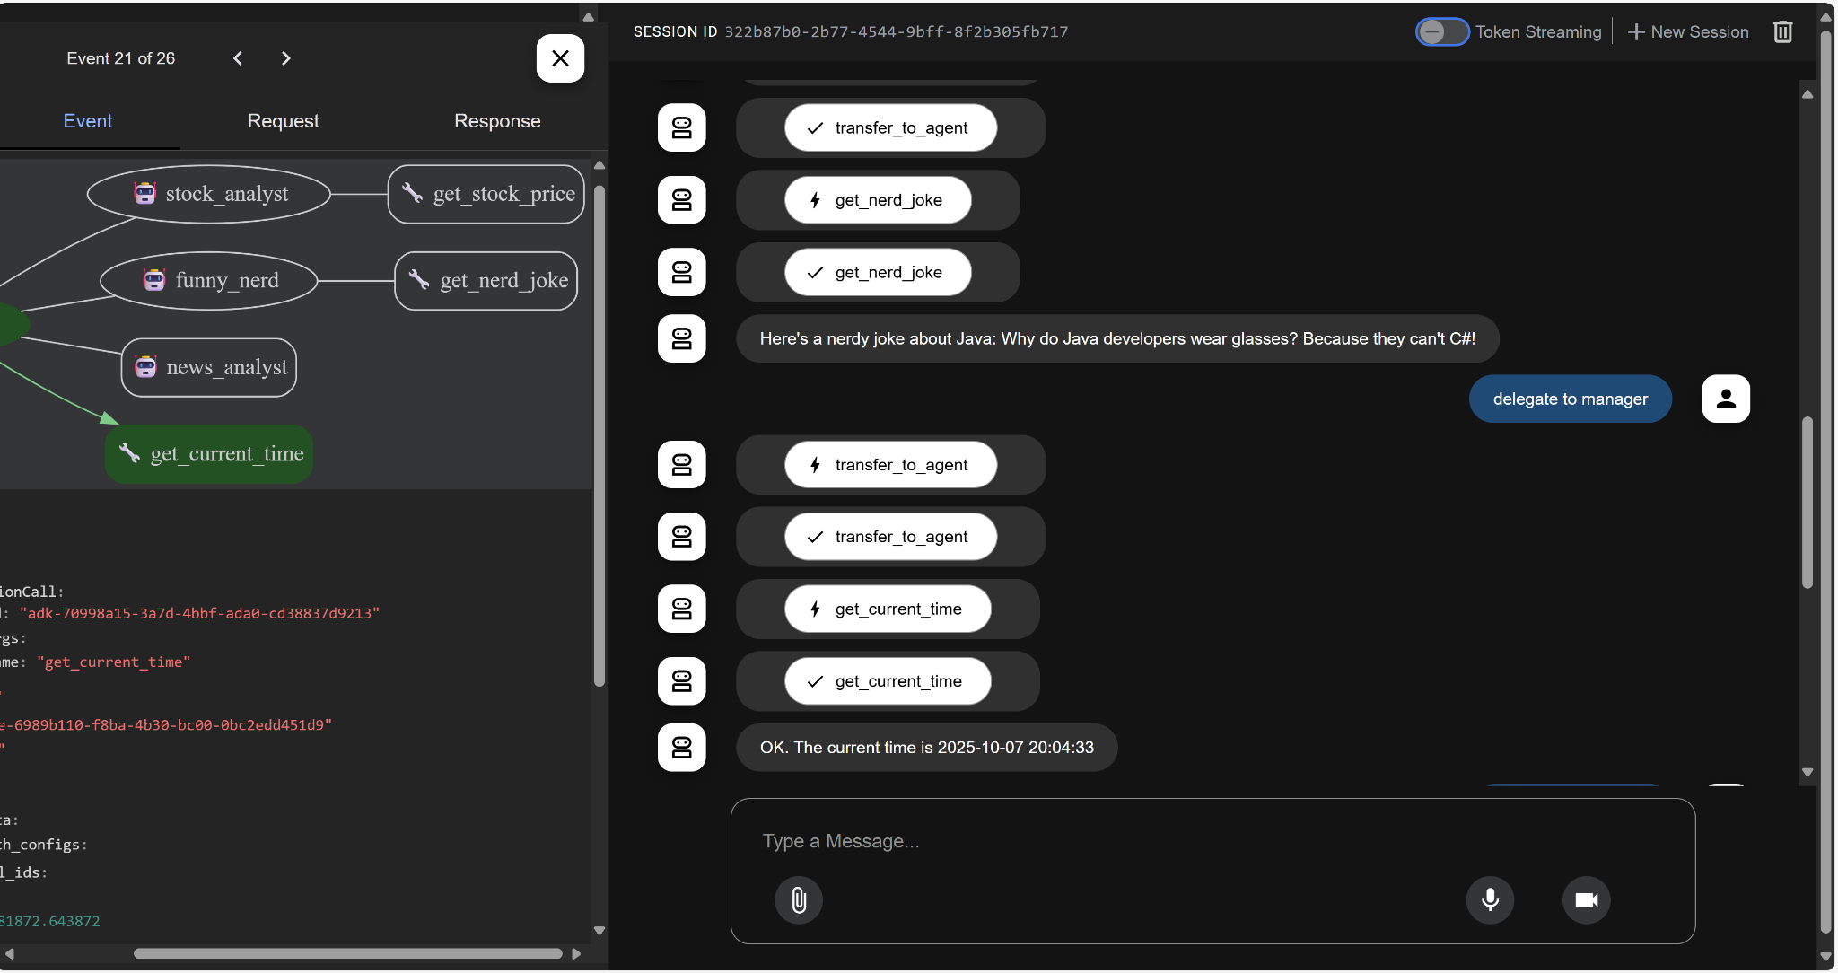

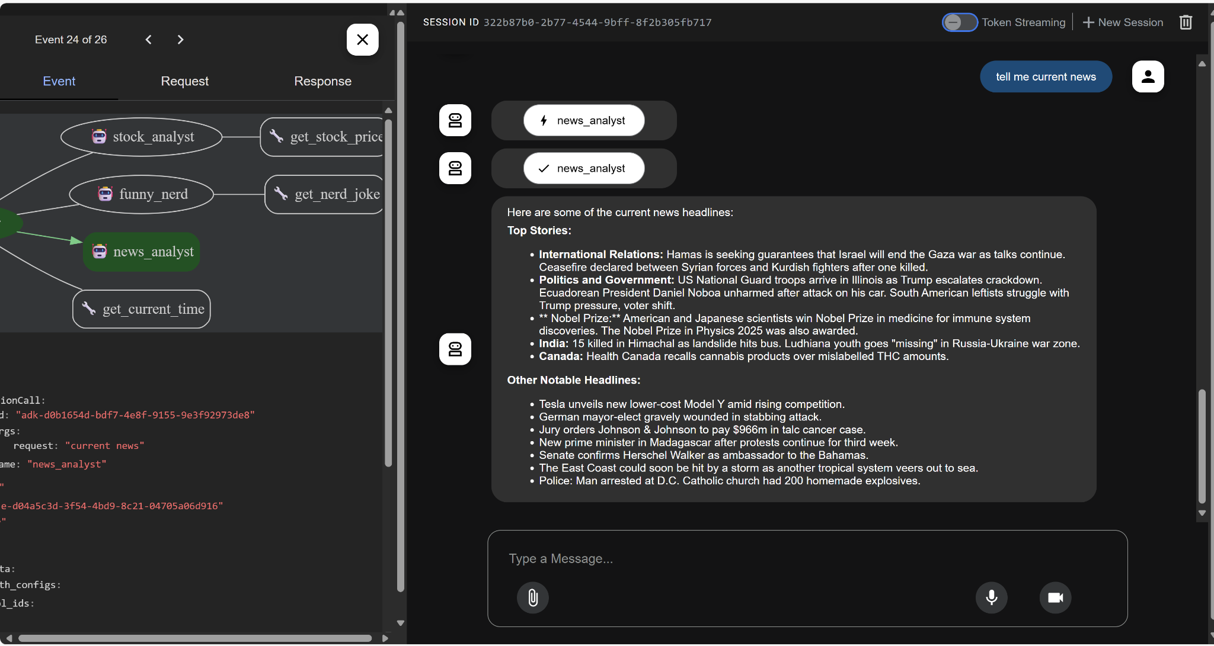

8 - stateful multi-agent: A complex version of multi-agent where there are a couple of sub-agents (policy agent, course support agent, sales agent, order agent) to the manager agent (Customer Service Agent), which lets the user get a list of available courses (sales agent), purchase a course (sales agent), know about its details (course support)and refund the code purchase(order agent) as well.

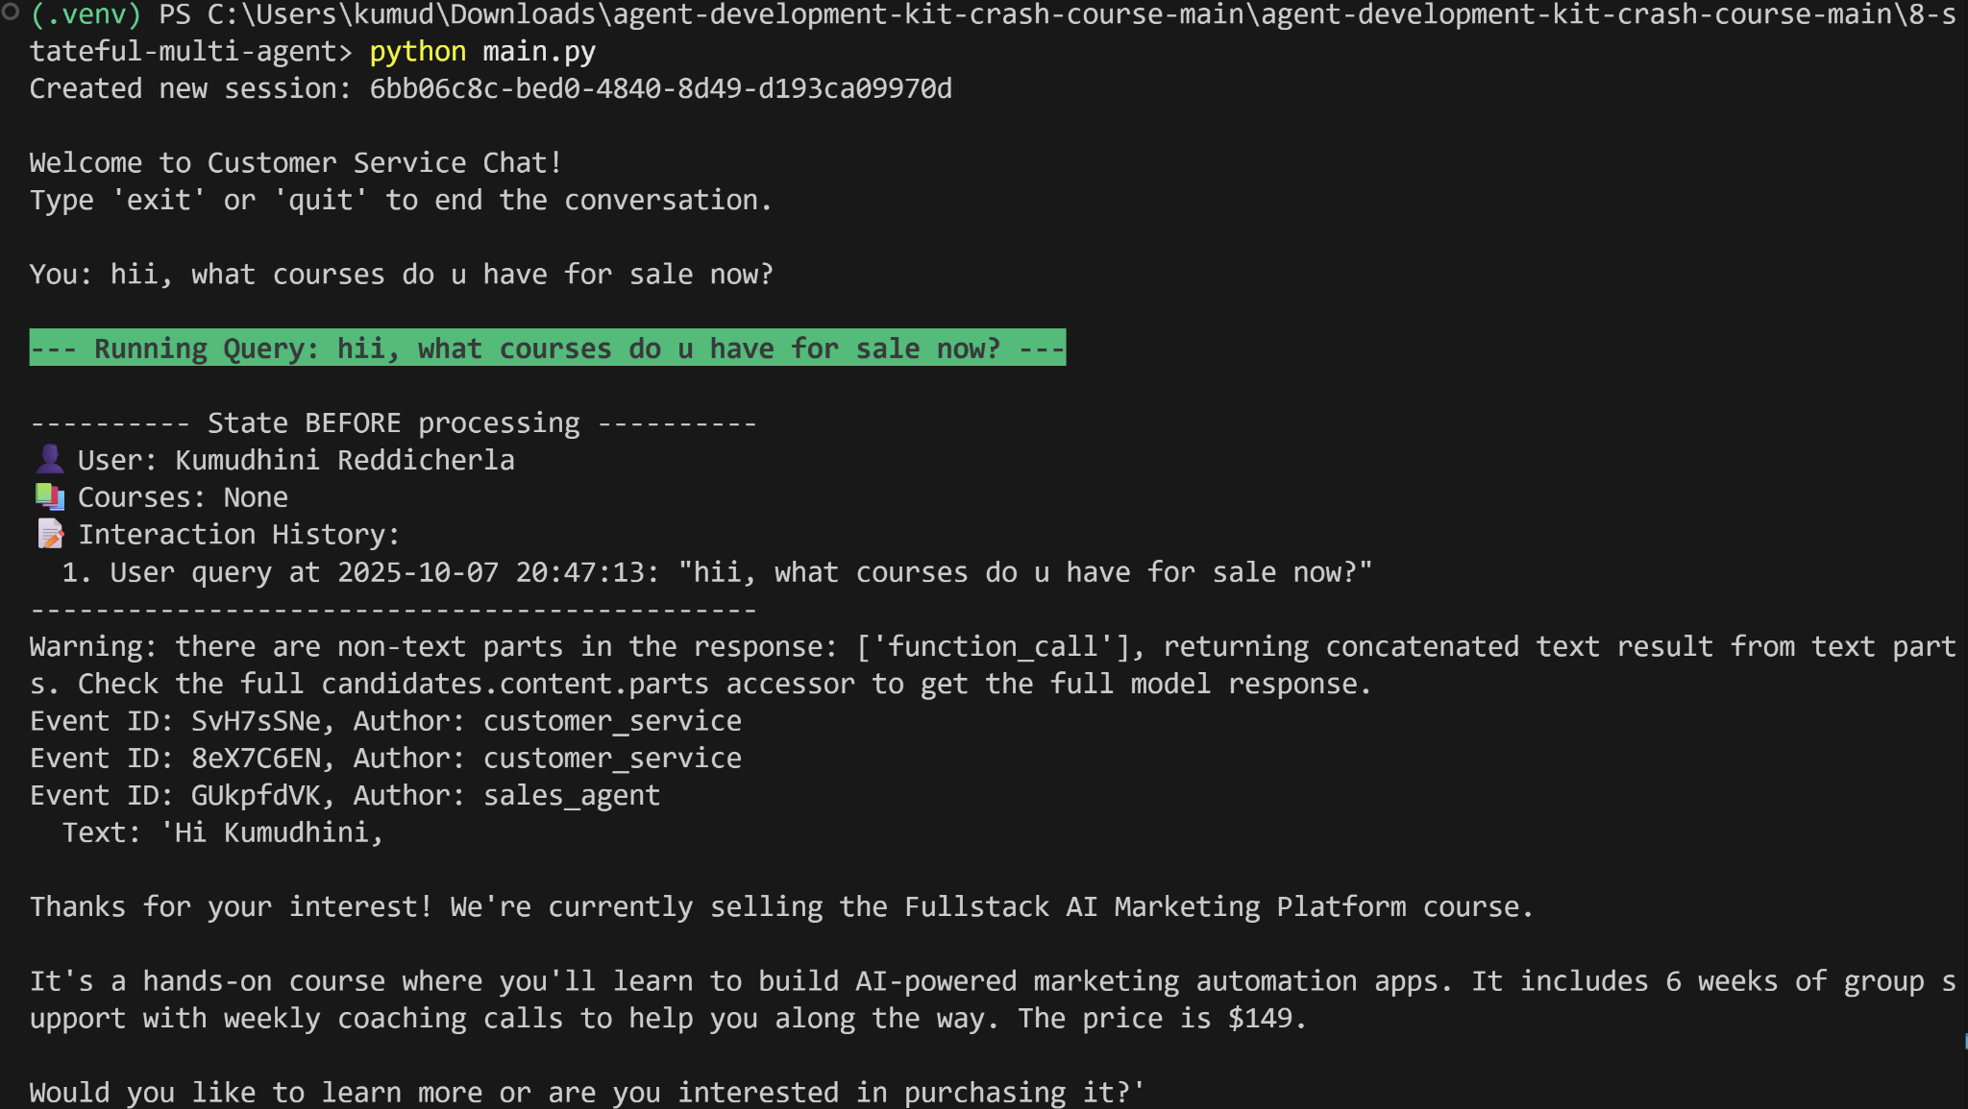

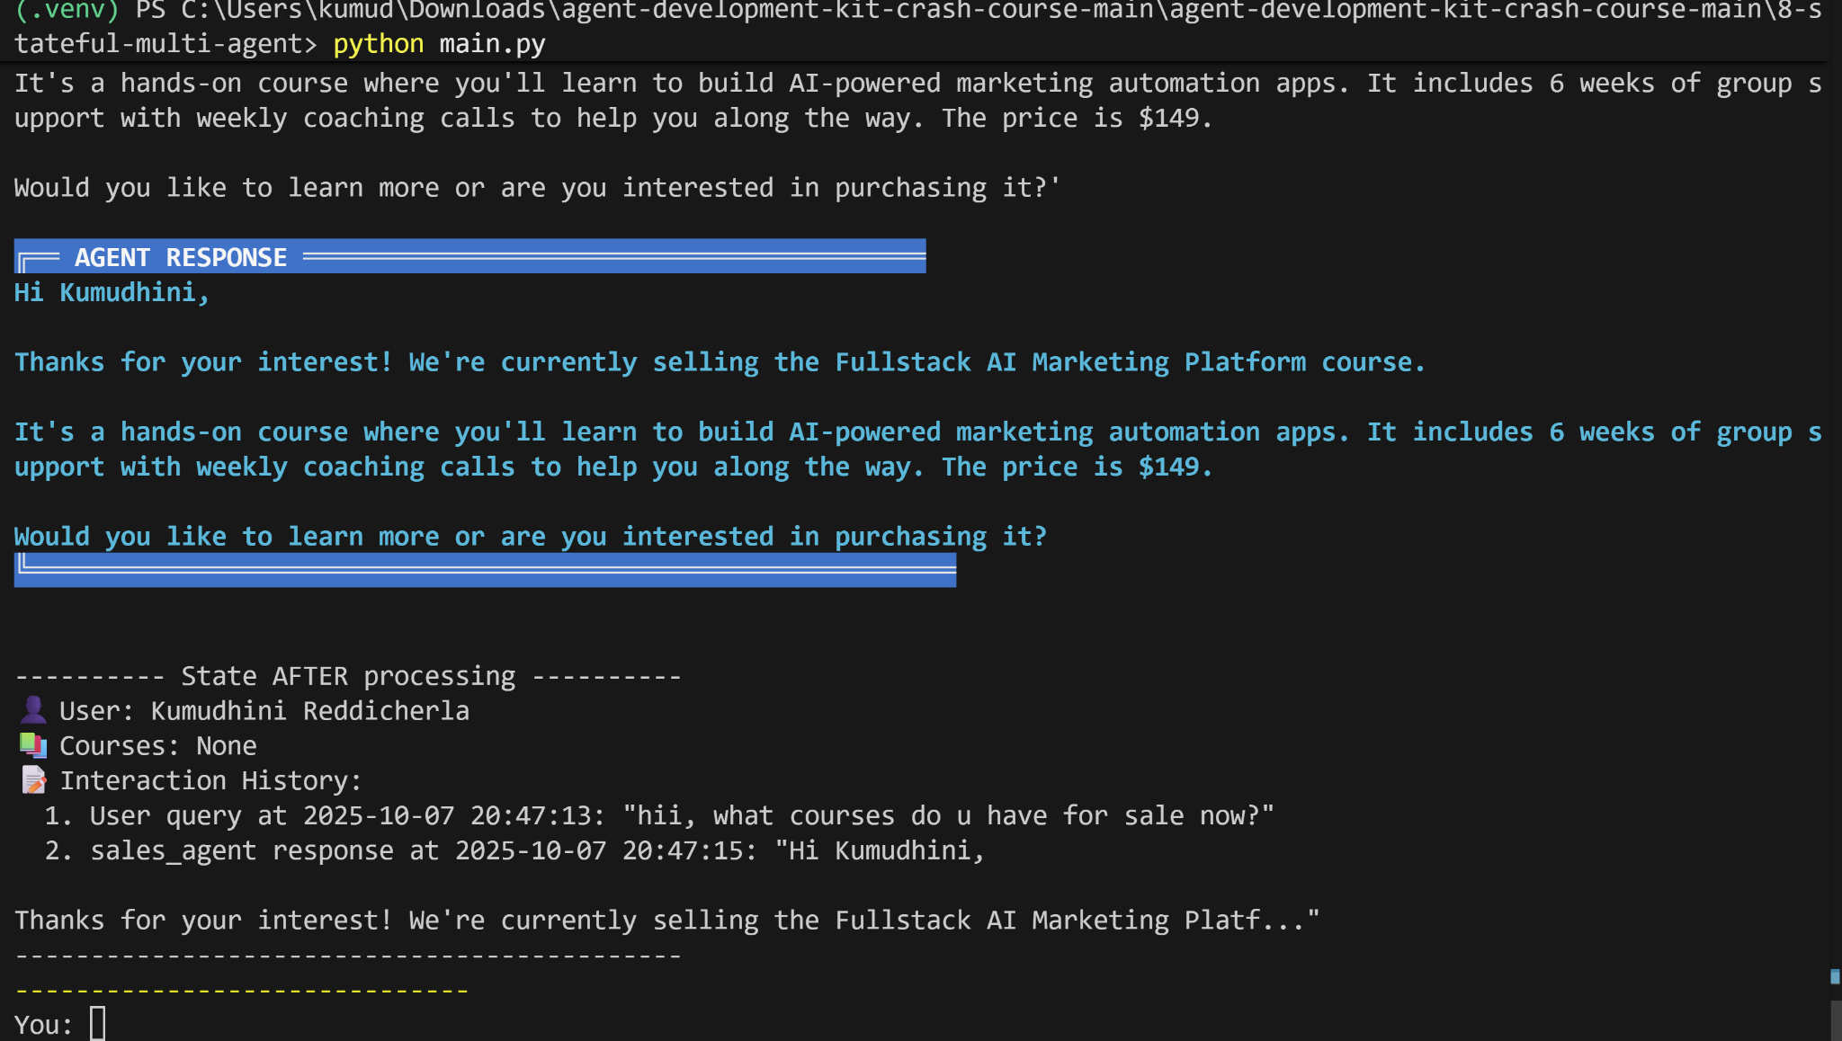

Purchase the course:

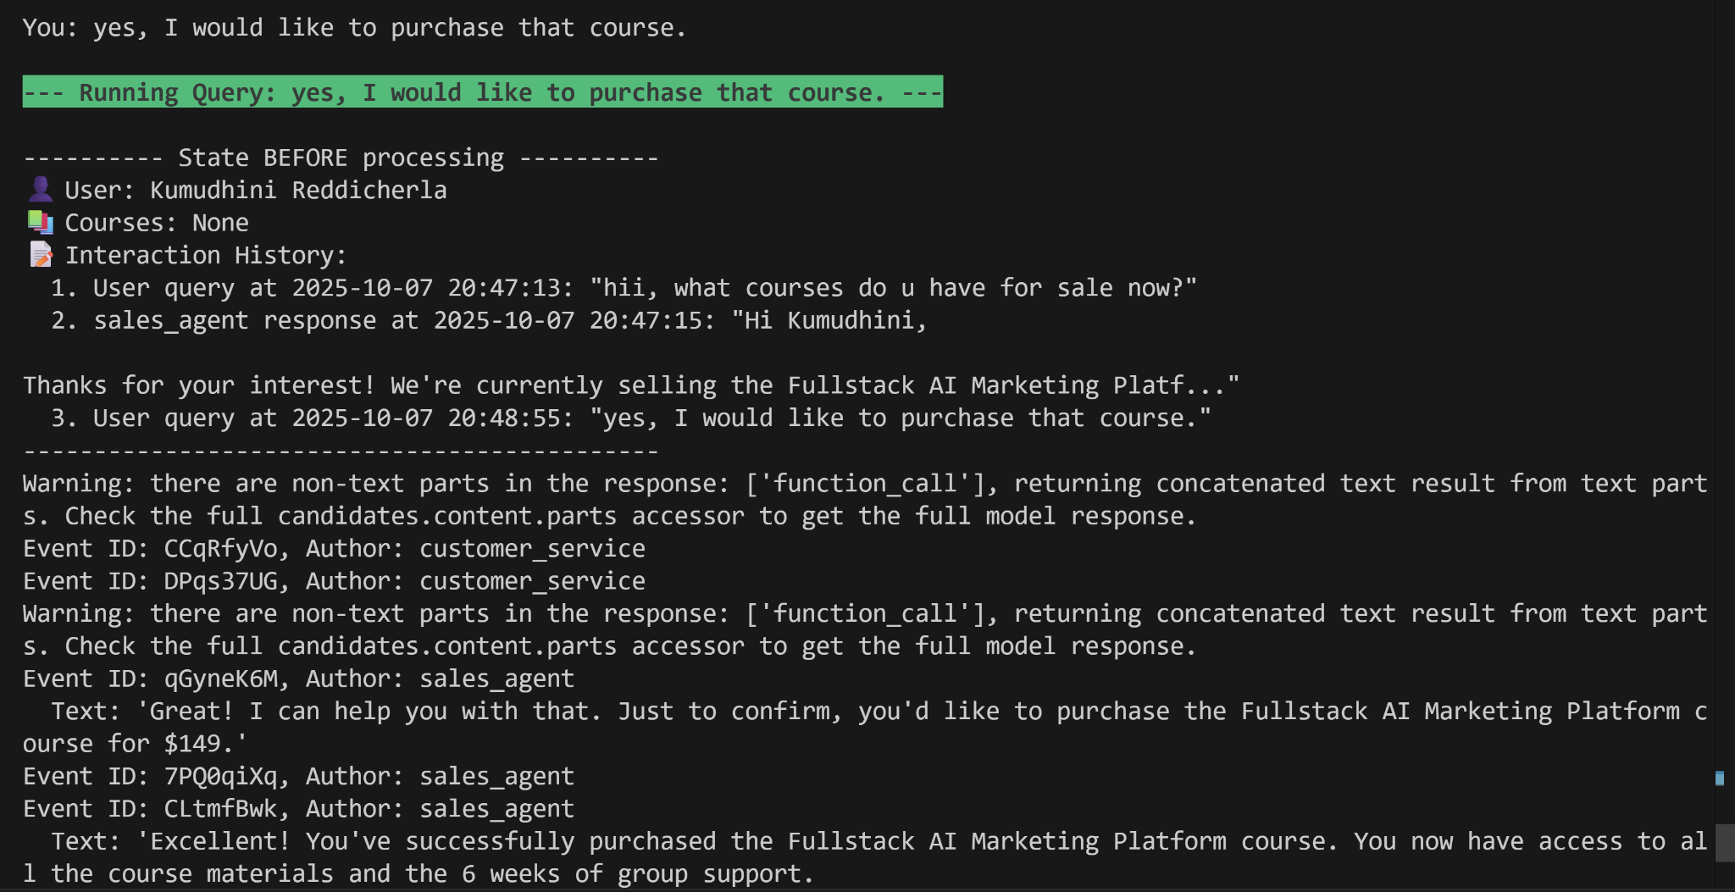

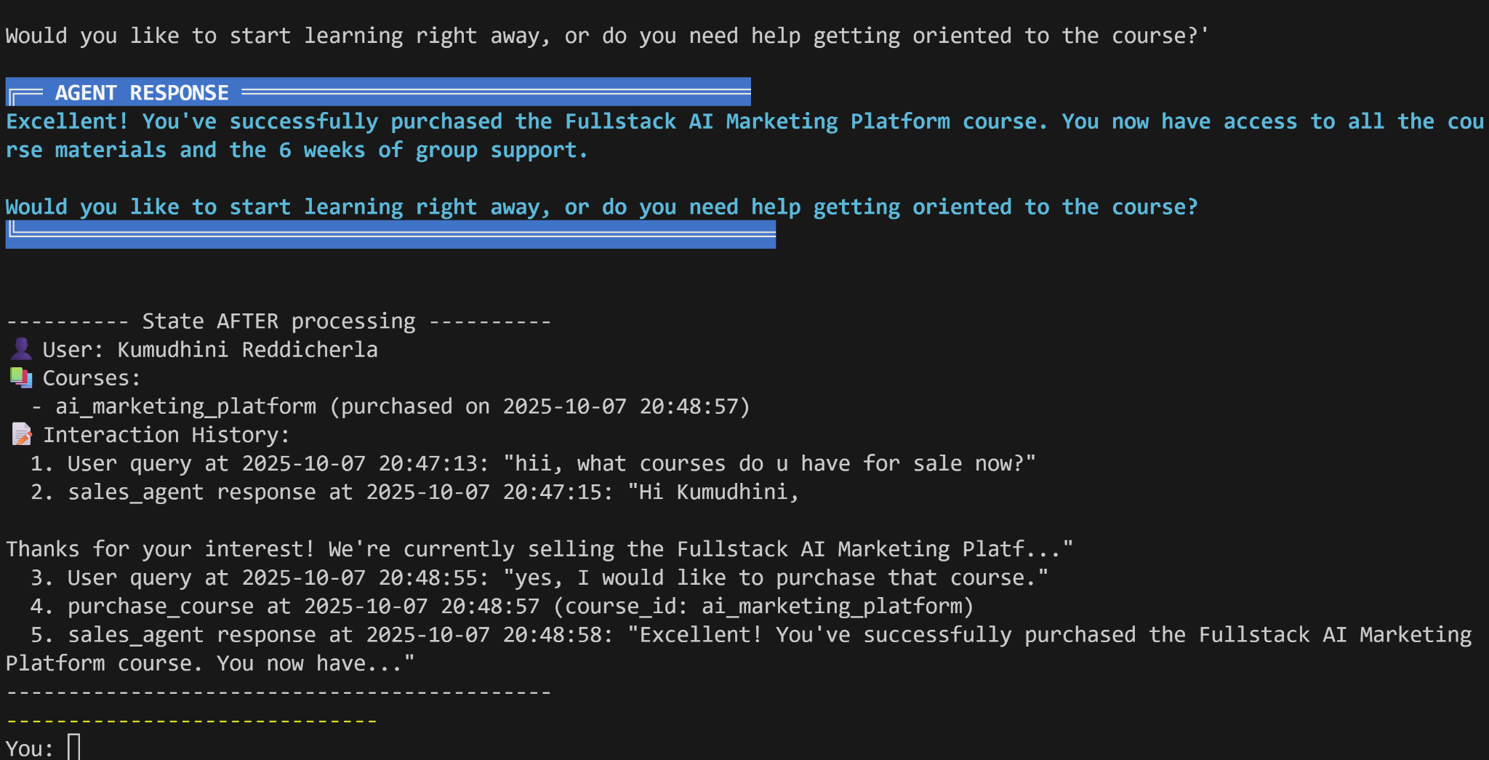

what are all the modules in the program?

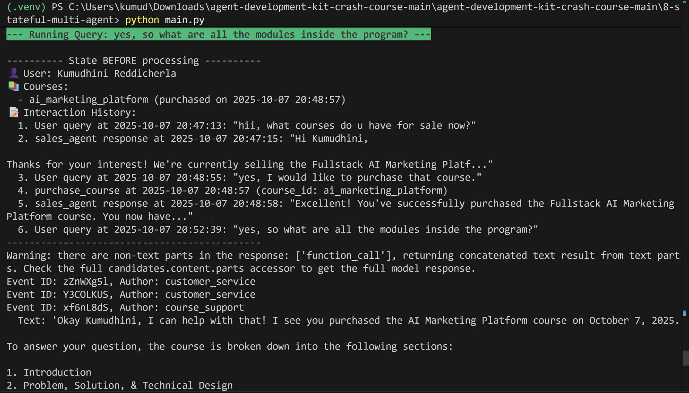

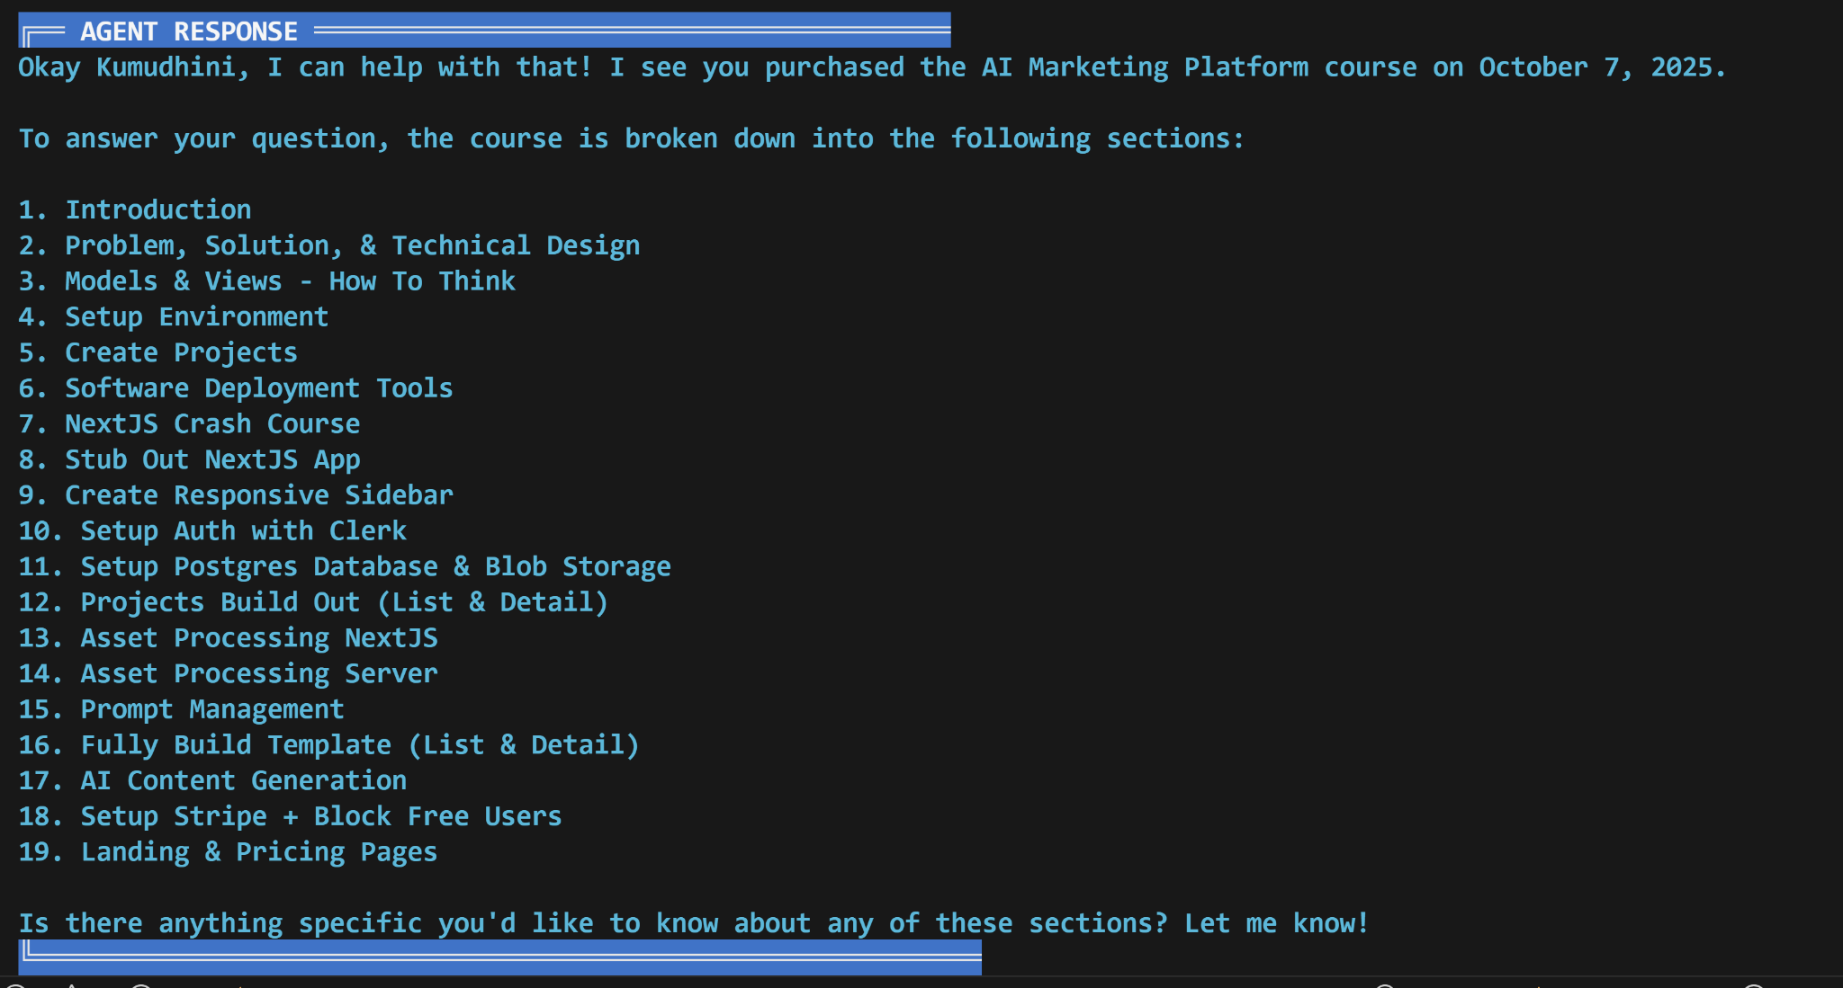

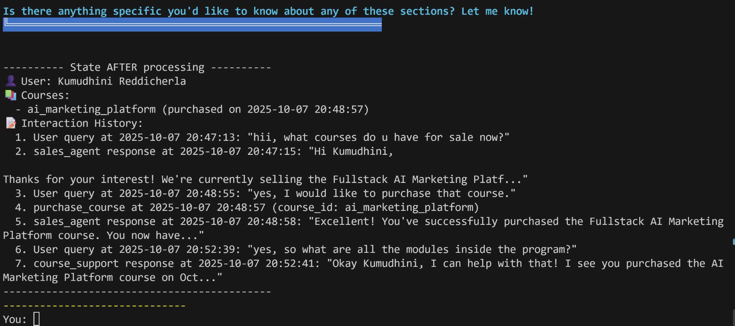

refund

